**The Formula of Vision**

The Interest and Influence Continuum

Pastors all over the world are seeking to find a perfect vision for carrying out

The Great Commission in their respective settings.

By understanding *The Interest and Influence Continuum* you will take a step towards unveiling God’s vision for your church to reach your city.

Where there is no vision the people perish. Proverbs 29:18 (Message - If people can’t see what God is doing, they will stumble all over themselves)

**The Difference Vision Makes**

Vision has been a difficult topic for many people to understand and use. It is often seen as an ambiguous, hard to clarify, attribute that

some churches value and others misunderstand. When comparing organizations side by side vision is often easier to grasp in practical

matters.

**Without Vision With Vision**

Various wins are celebrated Everyone celebrates the same wins

Inward focused Outward focused

Maintenance focused Growth focused

Spectators Participators

Change is life-threatening Change is necessary to meet goals

You can’t improve and avoid change at the same time. Maxwell

The role of the pastor has changed from the 1960's. At this time a congregation's expectations centered around the pastor's preaching

and pastoral care. "Today the senior pastor must be focused on being proactive in leadership, vision casting and centered on mission."

(Net Fax, "Helping Church Leaders Make the Transition from the Present to the Future," Number 80, September 15, 1997)

**The Great Commission**

The words vision and mission are often confusing. Here’s how we’ll define the two for our purposes today:

Mission is why your church exists - and your church’s mission has already been established:

If your mission is unclear, your morale will be low. Warren

**Matthew 28:19 Therefore go and make disciples of all nations, baptizing them in the name of the Father and of the Son and of**

**the Holy Spirit.**

**Vision Starts With Mission**

"The main thing is to keep the main thing the main thing." -Old German Proverb

Your church’s vision must reflect these three elements given to us in

**Matthew 28:19**:

**Go** - OUTREACH

It must be the goal of every pastor to reach as many people for Christ as possible. Weston

**Baptize** - WORSHIP EXPERIENCE (where life change happens)

**Disciple** – CONNECTION (to people and to purpose)

In our culture, your church will operate by OUTREACH, WORSHIP, and CONNECTION--to be a growing and healthy church your

vision must reflect the 3 elements...

**Vision is…**

Vision is how your church is **uniquely** equipped, empowered, and resourced to accomplish the mission.

The starting point for every church should be the question, "Why do we exist?" Warren

Vision is not just a slogan

Vision is not just a list of specific goals

Requires goals to ensure it’s continued quality.

Vision is not assumed

You have to compel people to move in the direction of the vision.

Vision is not self-sustaining—it will not continue if you walk away.

**The Search For Uniqueness Begins With**

**Discovering DNA**

Often pastors or leaders are frustrated when they don’t see people getting on board with their vision.

A common misunderstanding that we must address is that **you don’t take a vision to a church--you discover a**

**church’s vision.**

Every church and leader represents a combination of passions and personality

that are as unique as the strands of DNA that make up the human body.

You can't manufacture passion or "motivate" people to feel passionate. You can only *discover* what ignites your passion and the

passions of those around you. **We should only do those things that we can get passionate about***.* Collins

**The Church’s DNA**

To consider your church’s **past** and **present**, look at the church’s DNA:

Let’s use this church as an example:

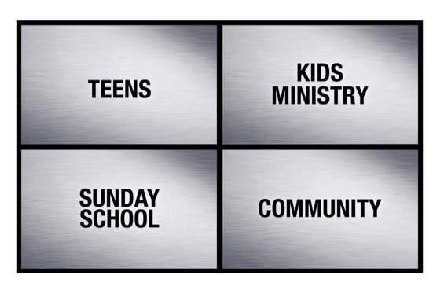

Research indicates that the average pastor’s tenure is less than 3 years, thus the church’s interests often trump those of the pastor.

Often your position of leadership does not compel your congregation to take on your interests.

**The Pastor’s DNA**

People don’t buy into visions; they buy into a leader. Maxwell

To consider the **future** of your church, look at the pastor’s DNA:

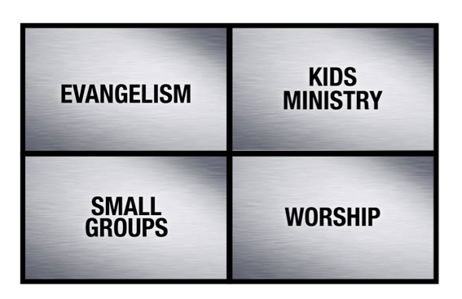

Culture is a product of leadership. Having a church culture is not optional. You will have one. You can either be intentional and

purpose driven about what kind of culture you create, or you can just let "what will be will be." Morris

**The Interest and Influence Continuum**

The pastor’s and the church’s DNA are not likely to be a perfect match:



Church Pastor

If a pastor whose number ONE priority is Evangelism walks into a church where the established number ONE priority is Teens and tries to

establish Evangelism as the new number ONE priority, he will likely face a great deal of resistance.

**The Interest and Influence Continuum**

Early in your influence you should focus on areas that both you and the church are passionate about.

Start where you agree:

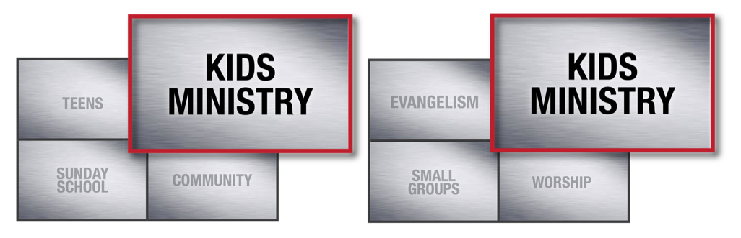

Church Pastor

I often advise leaders to spend less time trying to fix problems and more trying to create momentum. Maxwell

Over time, as you gain influence your interests will become their interests.

(VIDEO PORTION ENDS HERE)

**Defining Vision (The Hedgehog Concept)**

A first step for defining vision in your church is often to utilize a business principle.

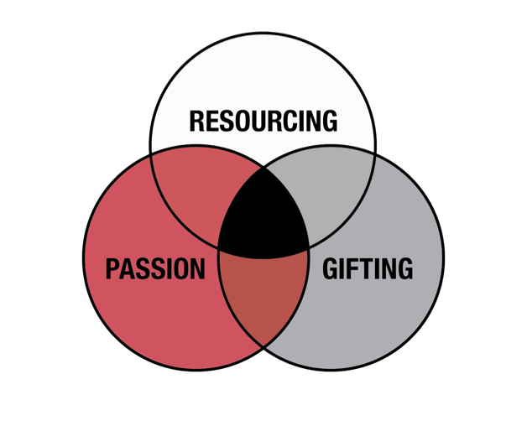

The Hedgehog Concept - a simple, crystalline concept that flows from deep understanding about the intersection of the following

three circles: (1) What you can be the best in the world at (GIFTING) (and, equally important, what you *cannot* be the best in the world at,

(2)What drives your economic engine (RESOURCING), (3) What you are deeply passionate about.

A Hedgehog Concept is not a goal to be the best, a strategy to be the best, an intention to be the best, a plan to be the best.

It is an *understanding* of what you *can* be the best at. Collins

See APPENDIX A for further explanation of The Hedgehog Concept.

**Discovering Vision (The Church Concept)**

Hedgehog is a business concept that we can apply to ministry in your church--4 blended circles

Find the common threads through all of these areas to discover your church’s

vision:

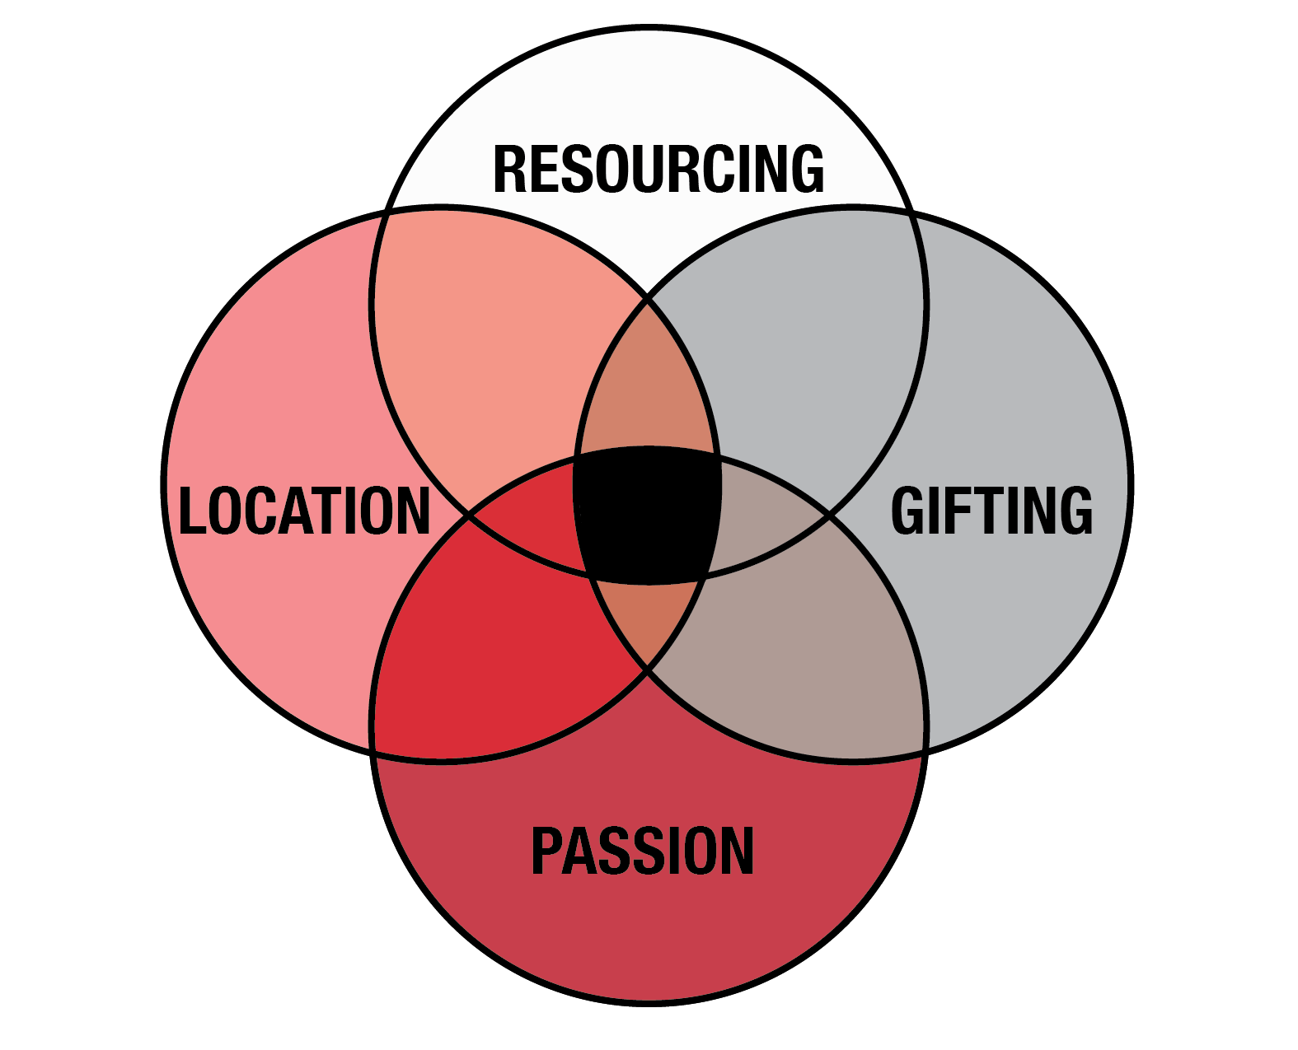

PASSION - What are people excited about?

GIFTING - What can we be the best at?

RESOURCING - Where are we best resourced to actually grow?

LOCATION - What are the needs of our area?

Example...**Passion** - an aging church wants to reach their children and grandchildren. **Gifting** -They have

a group of school teachers who are willing to serve and a pastor who doesn’t mind speaking on relevant family

issues. **Resourcing** - They have available budget and space for children’s facilities. **Location** - They are

located in an area where few other churches are targeting young families.

**Discovering Vision**

Another way to discover vision in your church…

Begins with a care or **CONCERN**

What is it you "can't stands no more" (POPEYE example)? Righting that wrong is a key to your vision for ministry. Morris

A God-ordained vision will begin as a concern. Stanley

Vision is born in the soul of one who is consumed with the tension of what is and what could be--God ordained vision will begin as

a concern. Stanley

Nehemiah 2 See *APPENDIX B* for Scripture and further explanation

Show the problem

To cast a convincing vision, you have to define the problem that your vision addresses. Every vision is a solution to a problem.

What is the need or problem my vision addresses? What will happen if those needs or problems continue to go unaddressed?

Stanley

Show the solution

When you link a problem that people are convinced needs to be solved with a clear and compelling solution, you have the

potential to capture their hearts. Stanley

Define how we can all be a part of the solution

As a leader, your responsibility is to make the people in your church discontent with where they are by painting a compelling picture

of where they could be. Stanley

**Discovering Vision**

You may be thinking *we already have an existing vision*

After 15 years of existence most churches will be in a dying phase. Weston

Vision counteracts stagnation. Vision is the catalyst for movement.

Reasons to consider a new vision statement at your church:

Perhaps your *interests* and *influence* are aligned but there is still no progress.

* + - * + Would a new vision statement encourage more of the church to be involved?
* Would a new vision statement create excitement in the church?
* Has the excitement for the existing vision statement dwindled?

Do your efforts focus more on equipping people or meeting their needs?

If everything worked out perfectly for your church, where would you be in 3 years?

What do you find yourself praying about the most (who’s here or who’s not)?

**Discovering Vision**

No matter what path you take to discovering or implementing your church’s unique vision for ministry, start with these 4 steps.

Step 1: Prayer

Proverbs 16:9 We can make our plans, but the Lord determines our steps. (NLT)

Step 2: Dreaming

Don’t have such a small vision that God doesn’t need to be involved.

Step 3: Brainstorming

Ex. think tanks, demographic study, prayer exercises, research other churches, etc.

Step 4: Challenging

Your vision will need to be tested and challenged. Discovering and implementing vision in a local church is a process, not just a *once*

*and for all* decision.

An interesting point in all of this is that Nehemiah spent the first 3 days after he got to Jerusalem in total silence. He spent 3 days in

total silence-what was he doing? He was evaluating the situation. The bible says that he rode around the city looking at the situation.

**Directing Vision – Alignment**

Once you have a vision you have to decide how it applies to your organization in a practical way.

The vision of an organization acts as it’s magnetic north. The Leadership Challenge

The way to build a bridge to the future is by creating GOALS and TASKS that carry the church toward the vision you feel God has

given your church.

Practical Steps for Directing Vision:

* Create a not-to-do list

Churches are notorious for creating competing systems, wherein unclear direction and conflicting information threaten to cause a

breakdown and paralyze ministry. Instead of replacing old systems, we tend to just download and add whatever is new to what already

exists. Stanley

Create a "not-to-do" list outlining programs your organization SHOULDN'T do. In other words, decide now what you will never do.

Stanley

If you really want to make a lasting impact, then you need to eliminate what you do WELL for the sake of what you can potentially

do BEST. Stanley

* Resources

The more programs, the better, or so it seems. Yet in many cases, these programs, which drain the church budget of thousands of

dollars and demand thousands of man-hours, do little to produce fruit. Gene Wood

* Calendar

Misalignment usually happens gradually. And if it goes unchecked, it can wreak havoc on an organization. Stanley

* Relationships

Hire and empower only those people who understand and can implement the vision.

**Distinguishing Vision – Communicating**

Vision must be memorable, motivating, and mobilizing.

First, if your vision is going to stick in people's minds, it must be memorable. Stanley

Great services are important but you better have a vision that causes people to move to their next step (or you’ll never grow) - this is why vision is so vital.

Practical ideas for distinguishing vision through your brand:

* Graphics

*Vision, mission, and purpose documents are all created for an internal audience. A church slogan or positioning statement is created*

*for an external audience - the community around you. Such a slogan is less about leadership and more about marketing. Morris*

* Language

If the process is not clearly defined so that everyone is speaking the same language, there is confusion and frustration. Rainer and Geiger

* Environments

If your vision targets young families then your environments should be designed with them in mind.

* Simplicity

It is better to have a vision statement that is incomplete and memorable than to have one that is complete and forgettable. Stanley

If the vision is too complicated for people to embrace, nothing changes. Stanley

To have a simple church, leaders must ensure that everything their church does fits together to produce life change. They must

design a simple process that pulls everything together, a simple process that moves people toward spiritual maturity. Rainer and Geiger

**Distinguishing Vision**

Distinguish vision through repetition:

Casting a convincing vision once is not enough to make it stick. Twice isn't enough either. Vision needs to be repeated regularly.

Stanley

Visionary leaders will tell you when you get tired of saying something the people you are leading are just now getting it.

* + Preaching your vision

Vision should evoke emotion. And it's difficult to evoke emotion with an e-mail or a letter. Stanely

Preaching is perhaps the most important vision casting tool a pastor has at his disposal. Osborne

* + Tying programming to vision

Alignment is the arrangement of all ministries and staff around the same simple process. Alignment to the process means that all

ministry departments submit and attach themselves to the same overarching process. Rainer and Geiger

* + Celebrate vision

Psychologists tell us that what gets rewarded gets repeated. When someone brings a guest, celebrate with him. Searcy

Every organization celebrates something. But if your vision doesn't align with your celebrations, I assure you that what's celebrated will overpower the vision and determine the course of your organization. Stanley

A built-in time to celebrate a win in our organization is during baptisms on Sunday mornings. I'm convinced that our baptisms do

more to drive home our vision than anything else we do. Stanley

**Delegating Vision**

* Through your leaders - the Vision must extend beyond yourself

Before the process can be clear to the people in the church, it must first be clear to the leaders. Rainer and Geiger

People do not progress through the simple process because they hear it from the pulpit. People do not move through the process

because they see a purpose statement on the wall. As helpful as these things can be, people move because someone else brings them

through the process. Rainer and Geiger

* Through evaluation

There is no excellence without evaluation. Searcy

* Through modeling

Your willingness to embody the vision of your organization will have a direct impact on your credibility as a leader. Stanley

* Through measurement

Vision is the compass by which we steer our spending. It's the yardstick by which we measure our progress. It's the standard by

which we evaluate new programs and propose initiatives. Morris

* No matter what type of vision you end up with - you have to lead the charge

to accomplish it

People follow leadership, and if leadership is not moving in the same direction, then people are scattered. Rainer and Geiger

"Example is not the main thing in influencing others, it is the only thing." -Albert Schweitzer

You must begin leading your church like it is already bigger than it is, and then your church will catch up with you. Easum and Cornelius

**Two Things Only You Can Do…**

**Define reality** - Only the leader can define the present and direct the future.

Even the most convincing visionaries don't convince everybody, though. Some people just aren't going to make the trip with you.

Try to be all things to all people; you may just wind up being nothing much to hardly anyone.

As it relates to vision, the first task of any leader is to define reality.

Leaders not only define reality, but they also understand reality.

The difference between the nominal pastors and successful pastors is their ability to come out with a clear vision and lead his people

in that direction. Weston

**New or Improved** - Leaders must recognize that leading from vision does not constitute constant change or constant maintenance but an approach that allows

for discerning seasonal needs.

One of the skills that a leader must master is the inner sense that the organization constantly needs either **NEW** systems, processes,

and strategies OR it’s current systems, processes, and strategies need **IMPROVED**.

Every leader has to steer a course between radical changeability and inflexibility.

Sometimes you just have to trust that you see the big picture better than anybody else and that you know which tweaks to make.

**APPENDIX A**

In his famous essay "The Hedgehog and the Fox", Isaiah Berlin says, "the fox knows many things, but the hedgehog knows one big

thing." Foxes pursue many ends at the same time and see the world in all its complexity. They are "scattered or diffused, moving on

may levels," says Berlin, never integrating their thinking into one overall concept or unifying vision. Hedgehogs, on the other hand,

simplify a complex world into a single organizing idea, a basic principle or concept that unifies and guides everything. Hedgehogs aren't simpletons. Hedgehogs see what is essential, and ignore the rest. Collins

A Hedgehog Concept simplifies a complex world and make decisions much easier. But while it has crystalline clarity and elegant

simplicity once you have it, getting the concept can be devilishly difficult and takes time. Collins

You need *all three* circles. If you make a lot of money doing things at which you could never be the best, you'll only build a successful

company, not a great one. If you become the best at something, you'll never remain on top if you don't have intrinsic passion for what

you are doing. Finally, you can be passionate all you want, but if you can't be the best at it or it doesn't make economic sense, then

you might have a lot of fun, but you won't produce great results. Collins

**APPENDIX B**

SHOW THE PROBLEM

Nehemiah 2:17 Then I said to them, “**You see the trouble we are in: Jerusalem lies in ruins, and its gates have**

**been burned with fire.**

SHOW THE SOLUTION

**Come let us rebuild the wall of Jerusalem, and we will no longer be in disgrace.”**

DEFINE HOW WE CAN ALL BE A PART OF THE SOLUTION

18 I also told them about the gracious hand of my

God on me and what the king had said to me.

They replied, **“Let us start rebuilding.”** So they began this good work.

**The Formula of Vision:**

White Board

**Key Demographic:**

Define Reality

This doesn’t just call leaders to focus on changing the negative—defining reality means recognizing positives and negatives of your

church in balance. It is determining where you are and where you want to be and discerning the distance and direction between the two. Without intentional adjustment, your church in 5-7 years will be a 5-7 years older version of it’s current self.

Recognize what you want to continue to develop and what you do not want to continue to develop over the next 5-7 years.

Define Target

Your target demographic represents whom you want to reach and make the core of your church (Ex: young families, business

professionals, boomers, etc.). The bridge to reaching your key demographics lies in the discovery of two questions: What are their

specific desires? What are the general needs of their life stage?

Assess

What is the distance between our current state and reaching the target demographic?

What do we have to offer?

What are we willing to change?

If your target demographic requires an enormous amount of change and costs you your current group, you may have chosen the

wrong target.

**The Formula of Vision:**

White Board

**Movement:**

Many churches have targets and defined visions but struggle to see synergy. Alignment that creates movement is most likely their hurdle.

**Mapping** (What are the practical elements of the process?)

Experience—Worship

Connect—Connect Track

Grow—Life Group Serve—Ministry Teams

**Measuring** (Are people following the process?)

Worship attendance:

Retention Rate (goal of 25% of worship attendance)

Group Roster (goal of 80% of worship attendance)

Ministry Teams (goal of 50% of worship attendance)

**The Formula of Vision:**

Lab

***Checklist:***

* **Schedule** a private prayer day (concerning key demographic and overall vision) AND a sit down

with key leaders for a dream session for where your church could be in 5-7 years.

* **Read** *Good To Great* by Jim Collins OR *Making Vision Stick* by Andy Stanley
* **Meet**weekly (for 6 weeks) with your team to brainstorm how to align and communicate your vision.

**Discussion *Questions*:**

**?** List 10 reasons why people should attend our church...

**?** How would aligning your church’s schedule, resources, energy, etc. with your church’s vision change the

way the church functions?

**?** Are there any areas of ministry in your church where your (the pastor’s) interests and the church’s

interests are aligned but there is still no progress?